Comparable Sale | Sale No. 1
Property Type | Land Site
CAD ID: | 35248
Street Address: | TBD North Beaton
City: | Corsicana
State: | Texas
County: | Navarro
Land Size (SF): | 7057
Land Size (Acres): | 0.162
Sales Price: | $51,500
Date of Sale: | 11/22/2024
Unit Price (S/SF): | $7.30
Unit Price (S/Acre): | $317,889
Zoning: | GR (General Retail)
Configuration: | Regular
Topography: | Mostly level
Min Topo (Ft) | 425
Max Topo (Ft) | 427
Topo % Change | 0.47%
Access: | Inside
Utilities: | All available
Flood Zone: | X
Data Source: | North Texas MLS 20747858, Texasfile.com
Recorded Number: | 11019
Grantor: | Brandi and Joshua Wallen
Grantee: | Fernando Perez
Terms and Conditions: | Cash or conventional financing
Days on Market: | 35
Property Rights Conveyed: | Fee Simple
Transactional Status | Sold
Original Listing Price: | $59,500
Sale-to-List Ratio: | 87%
Additional Comments: | None.

Land Sale Comp No. 1
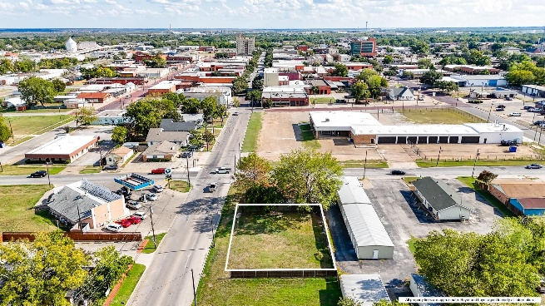 | 